**BUS ATTENDANCE SYSTEM THROUGH FACIAL RECOGNITION BY IMPLEMENTING AI INTEGRATION**

INTRODUCTION

In an era marked by rapid technological advancement and a growing emphasis on safety and efficiency, the traditional methods of tracking student attendance have become increasingly outdated and cumbersome. This project, titled "Bus Attendance System through Facial Recognition by Implementing AI Tools," presents a cutting-edge solution to this age-old challenge within educational institutions.

The primary objective of this project is to revolutionize the way student attendance is managed on college buses by harnessing the power of artificial intelligence (AI). Through the seamless integration of facial recognition technology and barcode scanning, this innovative system ensures that students are accurately identified, recorded, and accounted for during their daily commutes.

The key components of this system involve capturing a student's facial image and scanning their unique barcode (student ID). This data is then meticulously compared with an uploaded student database, allowing for precise identification and validation. Once this comparison is made, the student's attendance is seamlessly marked in the college's administrative system, recording essential details such as register number, name, department, year, date, and time.

One of the standout features of this system is its commitment to ensuring parental peace of mind. Whenever a student boards or disembarks from a college bus, an instant notification is sent to their parent's mobile number. This real-time communication fosters transparency and safety, enhancing the overall student experience.

Throughout this project, we will delve into the methodologies that underpin this sophisticated system. These methodologies encompass data collection and preparation, the development of a robust facial recognition model, barcode scanning implementation, secure database integration, attendance marking procedures, and the establishment of an effective notification system. Additionally, a user-friendly interface and administrative panel will be crafted to facilitate easy system operation and management.

As we embark on this journey to reimagine student attendance tracking, our project will prioritize security and privacy, ensuring that sensitive student information remains protected and that the system complies with relevant data protection regulations. Rigorous testing, comprehensive documentation, and ongoing support will be cornerstones of our project, ensuring that it not only meets but exceeds expectations.

With the fusion of AI, cutting-edge technology, and a commitment to efficiency and safety, this Bus Attendance System stands to reshape the landscape of student attendance tracking on college buses, ushering in an era of innovation and effectiveness in the realm of educational transportation.

**OBJECTIVES**

Develop a bus attendance system that uses facial recognition and barcode scanning to track student attendance, compare it with an uploaded student database, and record attendance information in the college system.

Additionally, the system also sends real-time notifications to parents' mobile numbers, informing them when their child enters and exits the college bus, ensuring peace of mind and safety for both students and parents.

**METHODOLOGIES:**

**1. Facial Recognition**: The system utilizes Facial Recognition technology to scan the faces of students boarding and exiting the college bus. This enables accurate identification and eliminates the need for manual attendance marking.

**2. Barcode Scanning**: In addition to facial recognition, the system also scans the student's ID barcode. This dual identification process ensures a robust and error-free attendance record.

**3. Student Database**: An uploaded student database serves as the reference for comparison during the identification process. The system cross-references the scanned data with this database to ensure the student's identity.

**4. Attendance Marking**: Upon successful verification, the student's attendance is marked in the college system. This includes registering the student's roll number, name, department, year, date, and time of boarding or exiting the bus.

**5. Parent Notification**: To enhance parent communication and safety, the system sends a notification to the registered mobile number of the student's parents whenever the student boards or exits the college bus. This real-time notification feature ensures that parents are informed about their child's whereabouts and ensures peace of mind.

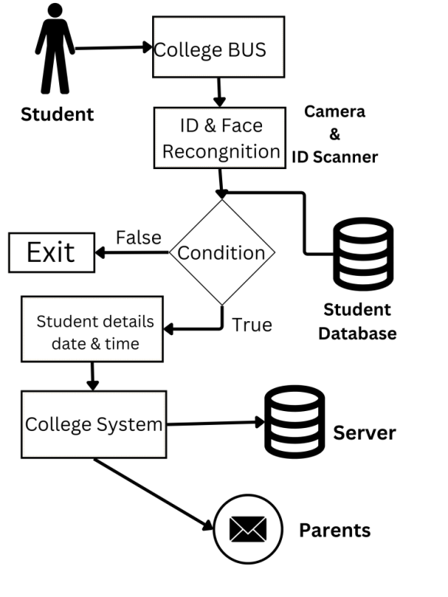

**Fig: Block Diagram**

**WORKING PLAN:**

1. Data Collection and Preparation
   * + Gather a comprehensive student database including register numbers, names, departments, and years.
     + Collect a diverse dataset of facial images of students for training the facial recognition model.
     + Implement barcode generation and scanning for student IDs.
2. Facial Recognition Model
   * + Train a deep learning model for facial recognition using the collected dataset.
     + Implement real-time facial recognition on the bus to identify students.
3. Barcode Scanning
   * + Develop a barcode scanning module to read student IDs.
     + Integrate the barcode scanner with the system.
4. Database Integration
   * + Create a secure database to store student attendance records.
     + Develop an API to connect the attendance system with the student database.
5. Attendance Marking
   * + Upon successful facial recognition and barcode scanning, mark student attendance.
     + Record attendance with student register number, name, department, year, date, and time.
6. Notification System
   * + Integrate a notification system to send SMS messages to parents' mobile numbers.
     + Send notifications when a student enters and exits the college bus.
7. User Interface
   * + Develop a user-friendly interface for bus drivers/conductors to operate the system easily.
     + Create an admin panel for managing student data and attendance records.
8. Testing and Validation
   * + Thoroughly test the system under various scenarios to ensure accuracy and reliability.
     + Validate the facial recognition and barcode scanning components.
9. Security and Privacy
   * + Implement security measures to protect student data and privacy.
     + Comply with relevant data protection regulations.
10. Documentation
    * + Prepare comprehensive documentation for system installation, configuration, and usage.
      + Create user manuals and troubleshooting guides.
11. Deployment
    * + Deploy the system on college buses.
      + Train bus drivers/conductors on system operation.
12. Maintenance and Support
    * + Establish a maintenance schedule for system updates and bug fixes.
      + Provide ongoing support to address any issues or concerns.
13. Evaluation
    * + Continuously evaluate the system's performance and gather feedback from users.
      + Make necessary improvements based on feedback and changing requirements.
14. Scaling
    * + Consider the potential for scaling the system to other college buses or institutions.
15. Compliance
    * + Ensure compliance with relevant laws and regulations, especially those related to data privacy and security.
16. Project Timeline
    * + Develop a timeline with milestones and deadlines for each project phase.
17. Project Team
    * + Assign roles and responsibilities to team members, including developers, database administrators, testers, and support staff.
18. Project Evaluation and Conclusion
    * + Evaluate the project's success in meeting its objectives.
      + Conduct a post-project review to identify lessons learned and areas for improvement.

**OUTCOME:**

* + Provides comprehensive solution for colleges to streamline attendance.
  + Helps in tracking, enhance security, and improve parent communication.
  + Improves operational efficiency, reduce manual effort, and provide an additional layer of safety for students.

**BUDGET:**

|  |  |  |
| --- | --- | --- |
| **S.NO** | **REQUIREMENTS** | **AMOUNT (in Rs.)** |
| 1 | Node MCU(Wi-Fi)  Cables, Connectors, ext.. | 3000 |
| 2 | Camera & ID Scanner  (Sensors) | 2000 |
| 3 | Software Development  Tools | 1500 |
| 4 | Cloud Server | 3000 |
| **TOTAL** | | **Rs. 9,500/-** |

**REFERENCES:**

1. M.M. Mansor (2009),” RFID based attendance system”, published in IEEE.

2. R. Santhana Krishnan (2021),"Secured College Bus Management System using IoT for Covid-19 Pandemic Situation", published in IEEE.

3. Mayank Srivastava (2020),"Real Time Attendance System Using Face Recognition Technique", published in IEEE.

4. Dalal Aljohar (2021),"Smart School Bus Tracking: Requirements and Design of an IoT based School Bus Tracking System", published in IEEE.